Diamond Kahn and Woods
66 Onslow Gardens
London
N10 3JX

Hi Bryony,

Please find attached a copy of the opening chapters of my novel, The Girl With Spiders for Hands and a full synopsis. It’s a quirky gothic fiction novel with a hidden environmental message, and a feel good factor. It’s a dark, strange, and unique story about being different and finding happiness.

Ara Von Destine is our protagonist. She has two large spiders for hands. Drac is her left hand, Frank is her right. She lives over the lake, isolated from Weavers Town, and can only visit around Halloween. On Devil’s Night each year, she crosses the lake to meet her only friend, Maverick Greene, who happens to be the Mayor’s son… and the Mayor is petrified of spiders. Everything unfolds into chaos when Ara is invited over to Maverick’s house and the Mayor unexpectedly meets the spider-hands. Later that evening, Ara finds herself being pushed into the huge spiders’ web on the edge of town. It transports her to another world. One without humans. A land filled with spiders, of all shapes and sizes, who claim that Ara has completed a prophecy. They crown Ara as their Queen, much to the annoyance of the previous spider monarchy. Is it all as wonderful as it seems? Does she finally belong in this new world? Spoiler alert, the previous Queen, Nida, is planning to take over the town and all they need is Ara to complete their deadly deeds.

The book is aimed at a variety of ages. I’ve tried to write it in a way that’s appropriate for both children and adults. The themes include, self-acceptance, love and owning the attributes that make us special. I think these are themes we continue to relate to throughout all stages in life.

From a young age I’ve always loved gothic fiction and spooky stories. Roald Dahl was a huge inspiration for me growing up, stories like James and the Giant Peach in particular. I also love authors such as Neil Gaiman and Terry Pratchett. I noticed quite a few books you’ve helped to publish are some of my favourites also: Meet Me In Another Life, The Midnight Thief and All Our Hidden Gifts.

I’m currently studying for an MA in Professional Creative Writing at Coventry University, where I’ve been able to explore various genres and writing styles. The course has pushed my writing in such a wonderful way. I’ve had some of my writing performed by actors in online charity concerts throughout lockdown. I also write custom monologues for actor showreels and teach young children (3-5 year olds) on the weekends.

I’ve looked at your agency profile on the website and think we’d make a really great team. Thank you so much for taking the time to look through my work and I look forward to your reply and any questions or queries you have,
Kindest regards,
Alexandria Wright

SYNOPSIS
The Girl with Spiders for Hands follows a teenage girl named Ara Von Destine. She lives with her intoxicated Aunt across the lake from Weavers Town. Ara feels isolated, but every year on Devil’s Night, she manages to cross the lake to see her only friend, Maverick Greene. It’s the only time of year she can visit without scaring the townsfolk, who think her two large spider hands are a Halloween costume. Ara’s left hand is called Drac, whilst her right spider-hand is called Frank.
Ara and Maverick meet at the infamous Widow Tunnel, rumoured to be haunted and deadly to anyone who gets too close. Maverick invites Ara over for dinner, as his mother and father are due to be working late that evening. Maverick’s mother is the Weavers Town Mayor, and she has a well-known fear of spiders.
Ara had never been to anyone else’s house before, so she accepted the invitation. The pair go to his house and Maverick makes her food. They then hear loud banging from upstairs. It turns out to be Maverick’s father, Mr Augustus Green, whose wife hadn’t needed him to work that night.
Mr Greene interrogated Ara, fascinated by her spider-hands. They lose track of time and Mayor Greene’s car pulls up on the driveway. Ara, Maverick and his father try to find somewhere for her to hide, but the best Ara can do is hide her hands behind her back.
A fly soon foils any chance of Ara hiding her hands, as Drac and Frank try to eat it. Mrs Greene catches a glimpse of the hands in the window reflection and after one of them attempts to bite Maverick, Mrs Greene tells Ara to leave.
Mr Greene lets it slip that on Halloween Night, the Widow Tunnel is due to be demolished. Ara goes to say her last goodbyes, only to find herself captured within its web. Someone had pushed her. Ara gets cocooned in silk.
She wakes up in a slightly unfamiliar place, New Weavers Town. There are no humans, only spiders, who can talk and are larger than the average size. The spiders reveal to Ara that they’ve been waiting for a girl who is half human, half spider to set them free on the eve of Halloween. Ara is crowned as their Queen, much to the annoyance of the previous spider queen, Nida.
Ara tells them of Mayor Greene’s plan to destroy the Widow Tunnel. The spiders couldn’t leave the tunnel without a vessel. The vessel being Ara, who quickly learns that Queen Nida is plotting to take over the original Weaver’s Town once they’re free.
Ara confronts Queen Nida, who then traps Ara in a carriage made of webs.
The spiders escape the tunnel. They begin a war with Ara as their mascot.
Ara manages to escape when Frank and Drac see a fly outside the carriage. They bit their way through, and Ara breaks up the battle. She demands peace between the humans and spiders.

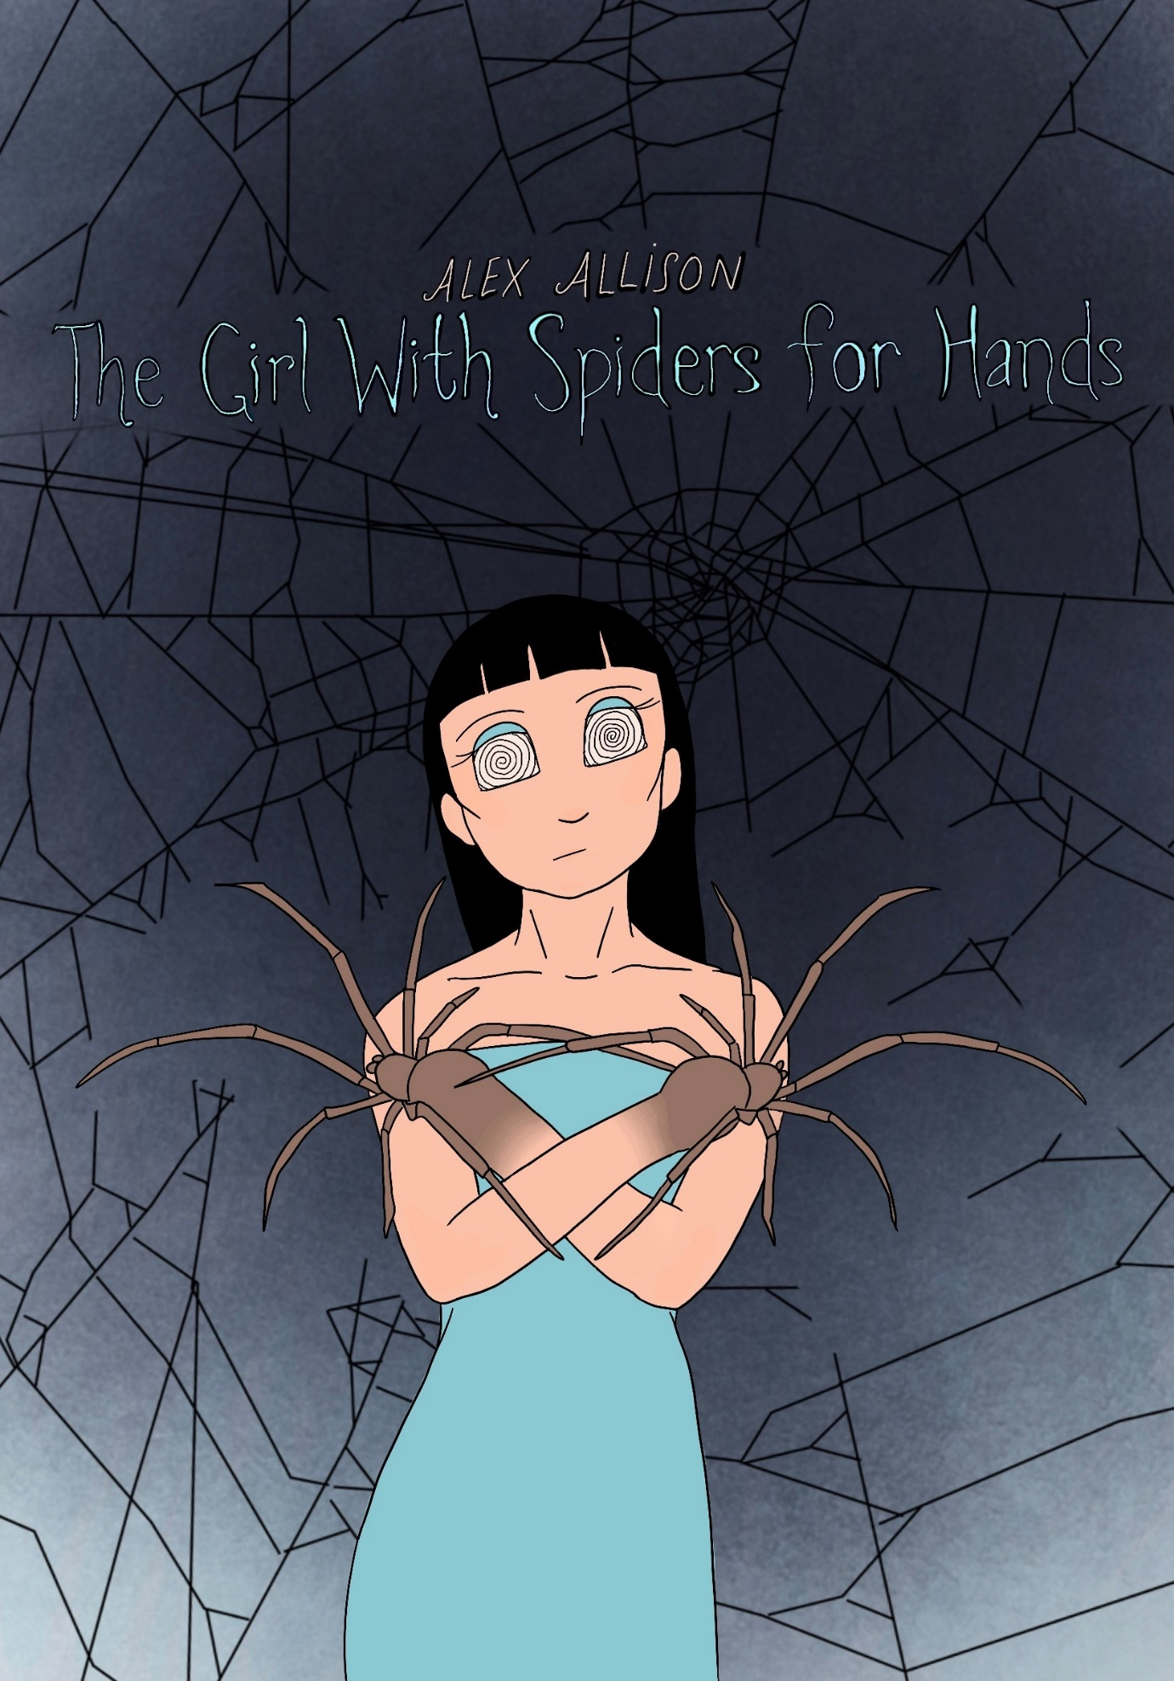

THE GIRL WITH SPIDERS FOR HANDS
By Alexandria Wright

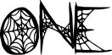

DEVILS NIGHT
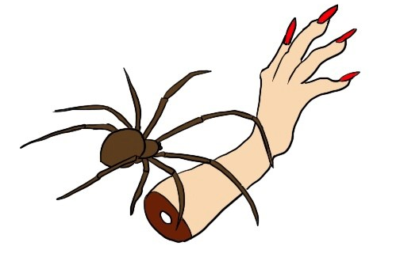

Ara von Destine looked down at her hands, or what used to be her hands. Instead there were spiders. Two large spiders, one for her left hand and one for her right. Each had eight long spindly legs, a set of sharp fangs and an array of glassy eyes. She’d given them names. Drac was her left hand and Frank was her right hand.
It was the night before Halloween, also known as ‘Devil’s Night’. The only time of year Ara and her spider-hands could enter Weaver’s Town.
The townsfolk were always dressed in extravagant costumes for the Festival of Fright. She fit right in.
Ara looked down at her phone and smiled, a text message from her only friend, Maverick Greene. They’d met five years ago, on Devil’s Night, by the Widow Tunnel. No-one dared to go near the Tunnel, for there were rumours and legends surrounding it. People had gone missing, never to be seen again. The Tunnel is also said to be the home of a million scorned spiders.
Maverick’s mother, the Mayor of Weaver’s Town, had declared to destroy the Tunnel when she was first elected. She’d nicknamed it, ‘The Eyesore of Weavers Town’, which Ara thought to be a bit dramatic, until Maverick revealed that his mother was petrified of spiders.
Ara and Maverick were the same age, going on eighteen. He went to school. She did not. Ara was home-schooled by her Aunt, who always drank too much around Halloween, providing the perfect distraction for Ara’s escape.
Long spider legs text Maverick back,

AUNTY’S FAST ASLEEP. SETTING OUT NOW.

Without waiting for a reply, she pushed the phone into the side of her sock and tiptoed out the house, leaving her snoring dribbling Aunt on the sofa.
Ara closed the battered front door as carefully as she could. Then, she crept into the small rowboat outside the house. Drac and Frank clutched the oars and they set off through the dark water. She could see the town in the distance. Lights and banners were being hung. Jack-o’-lanterns glowed. Music played cheerfully.
It didn’t take her long to cross the lake.
She met Maverick by Widow Tunnel and straight away, he said, ‘My parents are working late tonight. I was wondering if you wanted to come and see my house? Have some dinner?’ His cheeks were blood red.
Ara considered. What if his parents came back early? She felt a rush of cold air pass by them, and then she realised she’d never seen anyone else’s house before.
‘Maybe for an hour?’ She said, and they began the journey.



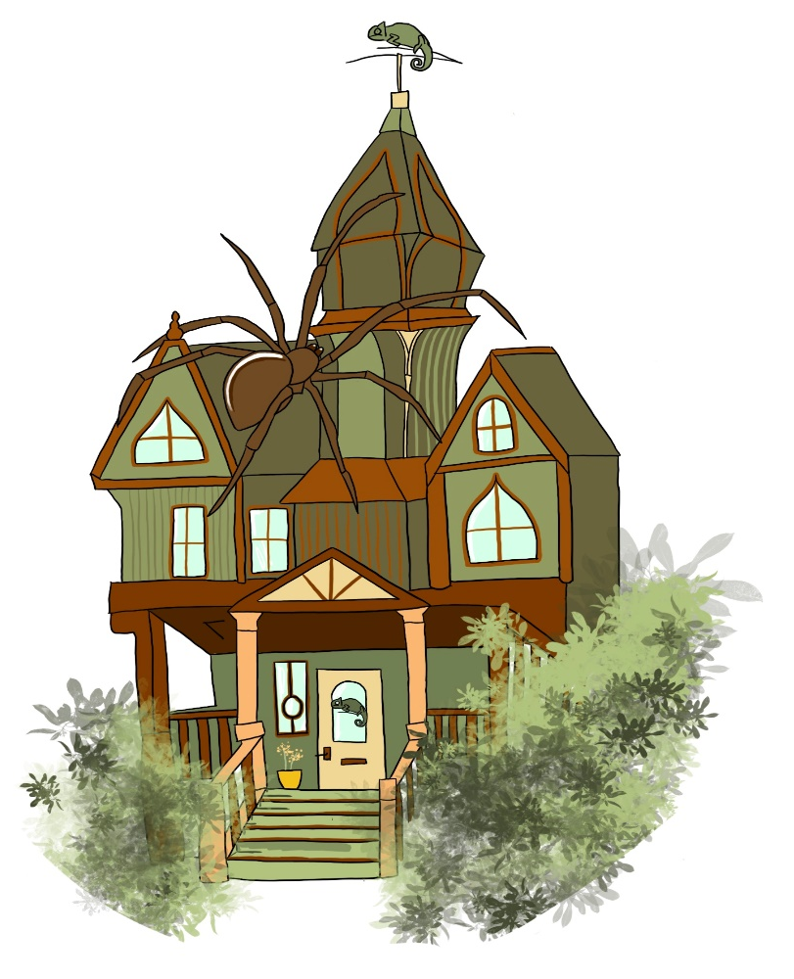
CHINA PLATES

Maverick’s house was one of the tallest in Weavers Town. Ara could tell it was expensive because it had fancy pillars and a set of stairs in the front. Its Victorian design was painted in kiwi and tangerine hues, trimmed with gold, and topped with a chameleon weathervane.
Ara marvelled at Maverick’s front door, the colour of sunshine, decorated with an iron knocker in the shape of yet another chameleon.
Since Maverick’s parents weren’t home, they didn’t need to knock. Instead, he lifted the potted chrysanthemums to reveal a hidden key, which he pushed into the lock.
The door swished open and Ara’s eyes sparkled. The flooring was made of glittering marble, and all the furniture was a crisp cream colour. The Halloween decorations were beautifully placed. Golden bats on strings dangled from the ceiling. A fake skeleton sat elegantly in the corner and there were bowls and bowls of toffee sweets sat on the hallway’s table.
‘There’s leftovers in the fridge. Hope you’re hungry.’ Maverick smiled, kicking off his boots. Ara copied him, leaving her small pumps by the front door, which he’d closed behind them.
Maverick offered her a toffee, but she politely refused, unsure if Drac and Frank would be able to open the fiddly wrapper. He seemed to understand, shoving a sweet into his own mouth, before guiding her to the kitchen.
As she followed him, her mouth hung open and her eyes darted from wall to wall, trying to take everything in. The spider-hands made noises of approval, itching to touch, but Ara kept them close. Maverick was already microwaving the food by the time she reached the table.
‘Hope you like chicken and veg?’ He asked, grabbing the cutlery, setting it on the table. She could only nod in reply, her eyes fixing on the chrome kitchen appliances. It was like a dream and Ara’s Aunt had always told her that if something seemed too good to be true, it often was.
‘Why are you friends with me?’ She blurted, her lips moving before her brain could stop them.
He seemed taken aback, and she almost regretted asking, until he said, ‘You don’t treat me weirdly.’ His freckled cheeks burned red. He flicked his long black fringe out of his eyes, avoiding her gaze. Ara noticed how long his lashes were. They were like spiders’ legs, she thought.
The microwave pinged.
Maverick moved, quickly scooping the food onto two china plates. The steam swirled in front of her face as he placed it on the table. The chicken was fragrant with thyme, sage and rosemary. The vegetables were salted and perfectly ripe.
Ara could feel Drac and Frank dribbling, her own mouth watered. She went to tuck in, devour the delicious meal, when a loud bang echoed from upstairs. She froze, looking toward the kitchen door, her spider’s legs dangling in mid-air.
‘Did you hear that?’ She asked.
Maverick nodded, his brows scrunching in confusion.
Another bang, followed by the sound of footsteps, coming down the stairs.

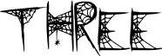

AT THE DINNER TABLE


Each footstep got louder and louder, until the noise stopped completely. The feet paused outside the kitchen door. Ara and Maverick held their breath. Ara was ready to attack the intruder, Drac and Frank opened their mouths and bared their sharp fangs. The spider-hands were vibrating with tension, making Ara’s arms shake.
The kitchen door swung open. They both gasped. There stood a short round man in a dishevelled grey suit. He had a bald patch on his head, surrounded by a ring of fading hair. Even his skin looked grey, Ara thought. The intruder made a startled noise upon seeing the girl for the first time. Mr Greene was taken by surprise but couldn’t seem to look away.
‘Dad?’ Maverick’s head tilted. ‘Why are you back from work so early?’
Ara dropped her hands to her sides, confused. His parents weren’t supposed to be home.
‘Your mother didn’t need me.’ Mr Augustus Greene responded, loosening his tie.
He moved to the fridge to get some leftovers for himself, putting them in the microwave. Maverick scowled. Ara could tell he didn’t want his father there, as he flopped sulkily into the seat opposite her.
Mr Greene made no signs of leaving the kitchen. He grabbed some cutlery and set them at the head of the table, all the while openly staring at Drac and Frank. Studying them. It made Ara’s stomach churn.
‘And who is this?’ Mr Greene pointed at Ara. He seemed to want a formal introduction. Ara looked from one Greene to the other. There was a tense energy surrounding them that she couldn’t quite put a name to.
‘This is my friend, Ara.’ Maverick mumbled, refusing to make eye-contact with his dad.
‘A friend from school?’ The older man quizzed.
‘She’s home-schooled by her Aunt.’ Maverick replied.
‘How’re you finding home schooling, dear?’ Mr Augustus Greene smiled unnaturally. It was a painful smile. Ara thought his tombstone teeth looked like they’d been smashed up and glued back together again. She tried to imitate him. She’d heard imitation was the highest form of flattery. However, her smile wasn’t as dazzling as Mr Greene’s, her right eye twitched smaller than the other and her cheek quivered from the effort.
The microwave pinged and Mr Greene took his seat. Ara noticed his protruding belly, through the gaps in his shirt fastenings, as he sat back in his chair. He repeated his question when she didn’t answer. ‘I said, how’re you finding home schooling?’
Ara snapped out of her observations, ‘My Aunt gave me detention in digital technologies last week.’
‘Oh? Why was that?’ Mr Greene replied, features frozen.
‘I said I wanted to be a web developer.’ She beamed, wriggled her spider-hands.
Maverick snorted, almost spitting out his drink. Mr Greene, however, was not best pleased.
‘So, you want to be a comedian, ay?’ He said.
‘I don’t really know what I want to be.’ Ara shrugged.
‘Can’t say there are many options for a girl like you.’ His wooden smile tightened further.
Ara looked down at her hands, a slight smirk on her lips. She didn’t care what Mr Greene thought of her, but Drac and Frank hissed, venom in their veins.
Mr Greene didn’t seem taken aback by the spider-hands reaction. In fact, he laughed and continued to stare at them in a dreamy wonder.
People always stared. Ara often wondered if they noticed anything besides her hands. Would they be able to recall her long dark hair with its ruler straight fringe? Or her mysterious hazel eyes, her pixie nose? Her thin smirking lips, her high cheekbones, or the turquoise dress she always wore with the matching eyeshadow that once belonged to her mother, the scar on her clavicle? She supposed not. Everyone who’d ever met her had only been interested in the ‘monsters’ on the ends of her arms.
Everyone except Maverick.
The legs of her spider-hands picked at the food in front of her. Drac, her left hand, pinched one of the diced carrots between its claws, as delicately as a convict trying to pick a lock, and dangled it into Ara’s mouth.
She chewed the carrot, falling into a daydream as her eyes scanned the photos on the walls. The pictures filled most of the largest wall. There were snapshots of a younger Maverick, beaming, in an Australian Youth football kit, waving a large flag behind his head. There were also snapshots of teenage Maverick, scowling, dressed in black jeans and dark shirts with bands printed across the front, ones Ara had never heard of.
There were many other photos, mainly of the family’s cat, who Ara hadn’t yet seen or heard around the house. Mr and Mrs Greene’s wedding photos hung proudly beside them. They were odd, she thought, as the celebration didn’t look happy, as weddings should. Both parties were stern faced, glaring down the lens with wide eyes. Ara hadn’t expected Maverick’s mother to look so uptight, for he was the exact opposite with his spiky hair and edgy personality.
The picture of Mayor Greene seemed to be looking back at her. Ara stared into the portrait’s sad eyes, which were bulging from their sockets. It was as if Mrs Greene had seen something horrifying right before the photograph was taken. Something she was petrified of.
Upon closer inspection, Ara noticed premature wrinkles on the woman’s forehead, bloodshot eyes, and dark circles. It was almost ghoulish. The puffed sleeves on the wedding dress and the bustled veil looked outdated, making the woman appear a rather ghostly bride. It sent a shiver down Ara’s spine. The same shiver she felt looking into Mr Greene’s stiff grin across the dinner table. She worried if he smiled any larger, the corners of his lips would start tickling the tips of his ears.
After a lengthy silence, Mr Greene spoke again, his mouth full of chicken. ‘I didn’t know what I wanted to be when I was your age. It wasn’t until I met Minerva that I finally found my calling. A job where I became useful. Take tomorrow, for example. We’re finishing off a huge project.’
‘What project?’ Ara asked as Frank fed her another carrot. She’d always wondered what the Mayor did, how her job worked.
Mr Greene spoke excitedly, in between mouthfuls of food. ‘The Widow Tunnel is finally being demolished.’
‘What?’ Ara and Maverick spoke simultaneously. They both looked at each other from across the table. The Tunnel had been the place where they’d first met. The place they returned to every Devil’s Night. The place only they were brave enough to visit.
‘Why are you demolishing it?’ Maverick frowned.
‘You know how your mother feels about spiders.’ Mr Greene scoffed. ‘We’ve been meaning to destroy it, ever since the last election.’
Mr Greene continued talking about policies and promises, about schemes they’d created with the prisons to help clean up the Town. Ara didn’t hear any of it.
A heaviness filled the air. Ara looked away from Maverick, her eyes focused on the kitchen window. Would Maverick still meet her next year if not by the Tunnel? There was something mysterious about the setting, something that was completely ‘them’ about it.
Outside, it had started to rain heavily. The weather matched her mood. Condensation had formed on the windows edge, highlighting the bat garland vignette and the fake cobweb decorations.
As she stared, something began to change. Ara’s pupils dilated. The blinding glow of two headlights shone through the glass, growing larger and larger the closer they got. The creak of the engine whined. The flames flickered within their pumpkin shell, and the skeleton decor trembled with terror.

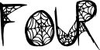

TICKING TIME BOMBS
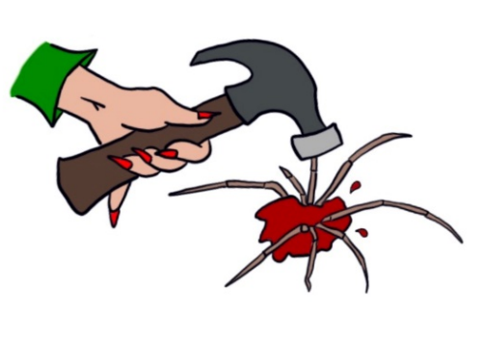

The gravelly grit crunched beneath the car’s rubber tires. Mr Greene stared into the beaming headlights as if they were the gates of hell, opening to swallow him whole. The screech of the vehicle ricocheted, followed by the click clack of the handbrake.
Ara watched the grown man tremble as the burr of the engine cut out. The headlights died, the car door slammed, the beep of the lock taunted and with each noise, Mr Greene looked warmer and warmer and warmer.
She glanced from Mr Greene to Maverick; who’s face had turned a washed out grey to match his fathers. Both men sat, frozen.
Mr Greene gulped. ‘Your mothers’ meeting must have ended early.’
The father and son’s eyes looked from Ara to her spider-hands. Frank and Drac twisted strands of chicken between their spindly legs. The men shared a look and were suddenly on their feet.
They didn’t have much time.
Ara rose from the table, following the men as they jumped around the kitchen. Maverick grabbed a cooking pot, turned it upside down and held it over Drac’s head. The spider shrieked loudly. With a shush from Ara, the pot was quickly discarded.
Mr Greene took off his suit jacket and covered Ara’s hands with it. Frank and Drac wriggled beneath it and they all agreed it would lead to further questions from the Mayor.
‘Ara, you’ve got to hide somewhere. My mom won’t like…’ Maverick signalled to Drac and Frank, apologetically. He couldn’t seem to find the right words, but it didn’t matter because Ara understood. The last thing she wanted to do was frighten his mother. The trio looked around the kitchen for a hiding spot, but the space was too modern, too open, too clean. Ara was too tall to fit into any of the cupboards and hiding behind the fridge was an impossible task. There were no closets. No back doors, no exits.
They were trying to find a way for her to hide beneath the table when the lock in the front door clicked. The rustle of a toffee wrapper echoed down the hall. Everyone, including the spider-hands, stopped. Time froze. Nobody moved. Nobody breathed.

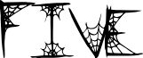

SPARKLING JEWELS
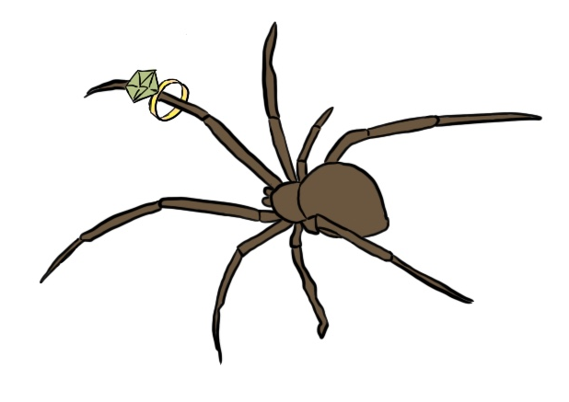

Ara came out from under the table. She’d be spotted instantly without a tablecloth to hide beneath.
As the kitchen door began to creak open, Ara could hear her heart thumping against her chest. It travelled up, pounding against her eardrums. The sound mixed with the palpitations of her spiders’ smaller heartbeats. The blood rushed to Ara’s head and she did the only thing she could think of. She shoved her hands behind her back.
Mayor Minerva Greene glided in, sparkling from head to toe. Ara looked from the wedding photo on the wall to the woman before her. She couldn’t make a single comparison. The woman in the photo was haggard, but Mayor Greene in person was dazzling.
She stood incredibly tall, towering over everyone in the room, including her husband. Ara had to tilt her head back to meet the Mayor’s eyes, which were surrounded by a pair of flamboyant green glasses. Her main features were pointed, from her nose to her lips cupid’s bow. Mayor Greene had a sharp strong chin and spiky cheekbones, even her body seemed to pinch in all the expected places, beneath its tight pear coloured suit.
Ara thought Mayor Greene looked the picture of political excellence. Not a single strand of hair was out of place on her head. It was quaffed up in an intricate design. Intricate like the jewellery she wore. There was a huge emerald necklace, surrounded by diamonds. A pair of chartreuse earrings, a green garnet ring, a chunky olive bracelet and, on Mayor Greene’s feet were the shiniest shamrock shoes Ara had ever seen.
Ara had never been the kind of person to openly stare at someone because she knew how it felt, but in the case of Mayor Greene, she couldn’t help herself. As she analysed, she wondered what it must feel like to be stared at for a nice reason.
Mayor Greene’s eyes met Ara’s and she smiled a similar grin to her husband’s wooden one. Ara felt unwelcome, even with her hands hidden.
Slowly the Mayor approached her, arm outstretched, expecting a shake. Ara held her breath, squeezing Drac and Frank tightly. The spider-hands fidgeted, snuggling beneath Ara’s long dark hair, legs entwining.
Ara took a step back when she felt the Mayor had gotten too close.
The sudden movement caused the Mayor to frown and retract her hand. Ara was glad she didn’t shake it. Mayor Greene’s fingernails looked sharp enough to pierce skin.
‘I’m Mayor Greene, and who might you be?’ She said, a harsh tone to her voice. Ara felt like she was being told off.
‘Ara Von Destine.’ She mumbled back.
‘Von Destine?’ Mayor Greene scratched her temple. ‘That name sounds familiar.’
Ara felt one of Frank’s legs crawling up her spine. She shrugged slightly, hoping the movement would prompt it to behave. ‘It’s -uh- quite a common name.’ She lied.
The wriggle seemed to go unnoticed. Ara could tell the Mayor was lost in thought. She seemed to be taking her time to place where she’d heard the name before. Ara looked over at Maverick and Mr Greene, who were wide-eyed and stood just outside of the Mayor’s eyeline. The tall woman tapped her pointed lips, until realisation flickered behind her eyes.
‘Oh yes! That’s where I’ve heard it.’ She announced. ‘We have two inmates at the prison under the name Von Destine. They’ve been helping to clear up the town under our new government scheme.’
Mr Greene sprang to life. ‘Ah yes! Speaking of which, we have a lot of planning to do for tomorrow’s demolition, my love. Perhaps we should let the kids go out and have some fun?’
Ara felt her body twitch uncontrollably. She was shaking from head to toe, trying to gain control. Drac and Frank had managed to free themselves and were taking matters into their own hands. A set of spider legs flicked out from behind Ara’s back, like strange skeletal wings.
Mr Greene quickly grabbed his wife’s arms. He twirled her around to face the opposite direction, stuttering nonsense to distract her.
Maverick moved to stand beside his friend as the spiders flew out and into the open.
‘What’s happening?’ He whispered to Ara, but she couldn’t respond. The hands were trying to overpower her. She couldn’t figure out why. They’d never denied her control before.
Mayor Greene tried to turn back around, but her husband guided her away with another thought.
Ara’s arms flung through the air. She pulled them backwards with all the strength she had, but they didn’t want to cooperate. Drac and Frank’s mouths snapped wildly, their fangs dribbled.
‘What are you doing?’ She hissed at them; her shoulders shook as she fought their strength. The spider-hands looked up with glistening, hungry eyes. It was then that Ara knew what was happening and she stopped fighting them. She listened as carefully as she could.
Underneath the sound of Mr Greene’s ramblings, Ara zoned in on a much quieter noise. She could hear a soft buzz. It was barely audible. The hum zipped from the top of the door to the leftovers on the table. It got swatted as it passed Mayor Greene, and it spiralled through the air to land on Maverick’s sleeve. He flicked it off. The buzz made its way to Ara.

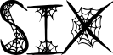
SIX SIX
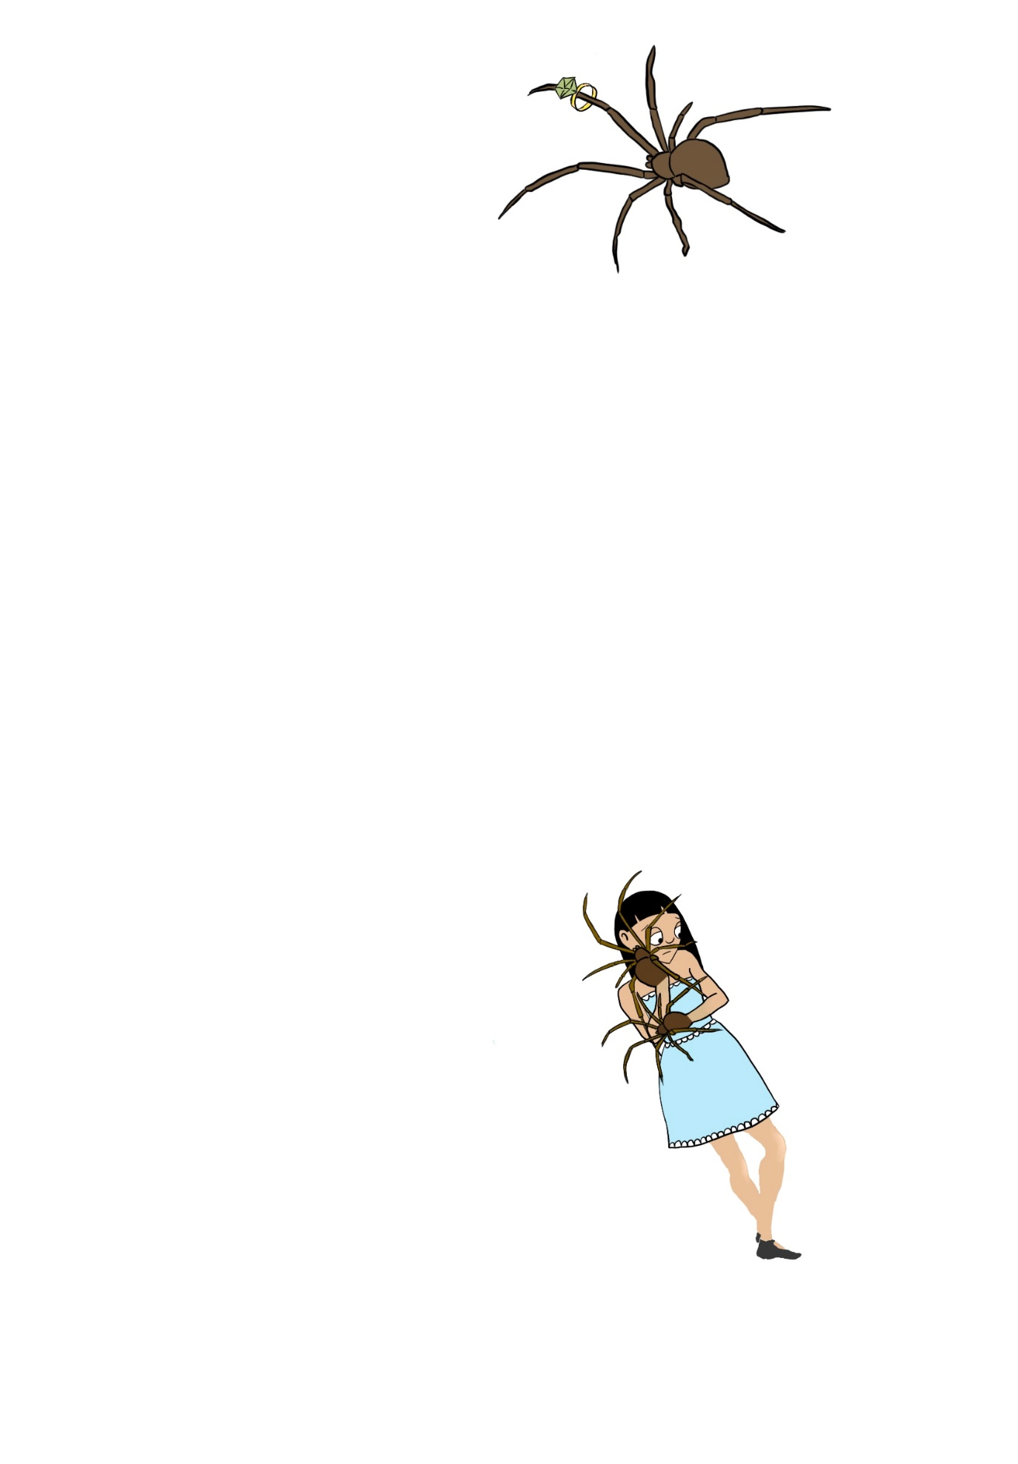

The fly was Ara’s undoing. Drac and Frank couldn’t resist biting whenever it came near. It circled the spider-hands. It teased them as it buzzed, just out of their reach. The fly rubbed its hands together, plotting its next move.
Ara tried to help Drac and Frank catch the fly. She hoped that once it was gone, she’d have control over her hands again. Maverick joined her, swatting at the insect. Ara wasn’t sure how much longer Mr Greene could distract the Mayor for. She was beginning to look frustrated.
Together Ara and Maverick waved and jumped, trying to grasp the fly. It sat stealthily on the light above the table, looking down at them from its pedestal.
Outside the house, the lightning crackled, and the thunder bellowed. The rain was pounding down against the window. With a strong bolt of lightning, a blast lit up the reflection in the glass and Ara’s eyes met Mayor Greene’s.
Ara saw the woman in the photograph staring back at her, eyes bulging, haggard and worrisome. Ara held Drac and Frank above her head in a warrior pose.
Mayor Greene could clearly see them and yet, she shook herself, not believing what was being reflected in the glass. She closed her eyes, and opened them again, her bottom lip shook violently.
Mayor Greene pushed her husbands’ hands off her arms and turned round to see if the glass illusion was reality. The sparkly necklace she wore dug into her neck as her breathing became heavy.
Ara didn’t dare move, her hands on full display. She could feel bile rising in her throat.
Mayor Greene looked into the many eyes of the spiders and stumbled backwards, pressing herself against the photo wall. Several pictures fell from their hooks. The sound of smashed glass echoed around the kitchen.
The fly buzzed down from its perch. Drac snapped viciously, desperate to catch the snack. Frank dribbled, following the insect with its front eyes, and occasionally reaching out to grab.
Mayor Greene shrivelled against the wall; a terrified whimper caught in her chest. Ara pulled, trying to stop the spider-hands from wriggling around. With each movement, Mayor Greene receded further and further into the wall. Mr Greene rushed to his wife’s side, trying to talk her round. Mayor Greene took her eyes off the spiders momentarily, to glance at the door, her only escape. Ara watched the woman wriggle from one foot to the other, her pointed fingernails digging into the wall.
Maverick pulled Ara to the opposite side of the room, to put some distance between his mother and her biggest fear.
The spider-hands protested. They hissed and whined the further away they were pulled. In the struggle, they knocked the leftover food off the table. Vegetables and chicken went plummeting onto the clean floor. Ara winced.
Maverick pulled her towards the corner of the room. The spider-hands fought to get back to the fly.
Drac went to bite Maverick, which caused a gasp to escape his mothers’ shaking lips. Maverick jumped backwards, letting go of Ara. The hands had never done that to him before.
The end finally came when the family’s cat slid out from under the fridge. It ran with confident speed. Its fluffy paws snatched the fly from mid-air. The cat crushed the insect with its sharp teeth and swallowed it whole.
Drac and Frank went limp with disappointment. The spider-hands dropped heavily at Ara’s sides. The weight of them caused Ara to fall to the floor, her body exhausted. Maverick slowly began to walk towards her. With caution, he took a few steps at a time.
‘Maverick! Stay away.’ His mother snapped, pushing her glasses up her nose.
Ara looked around the kitchen at the mess she’d made. The food she’d knocked from the table was being licked up by the cat. The smashed photos were looking up at her with disapproval.
She followed the shards of glass to Mayor Greene, who’s perfectly quaffed hair sprang out in places. She hadn’t moved from the wall and made no effort to. The events had unravelled so quickly. There was barely time to process.
‘Get out of my house.’ The Mayor said firmly. She met Ara’s eyes, refusing to look at the spider-hands. Ara was nervous to move. What if she didn’t have full control back? She stared back at Mrs Greene.
‘I said, Get Out.’ and Ara ran.



SCATTERED STARS
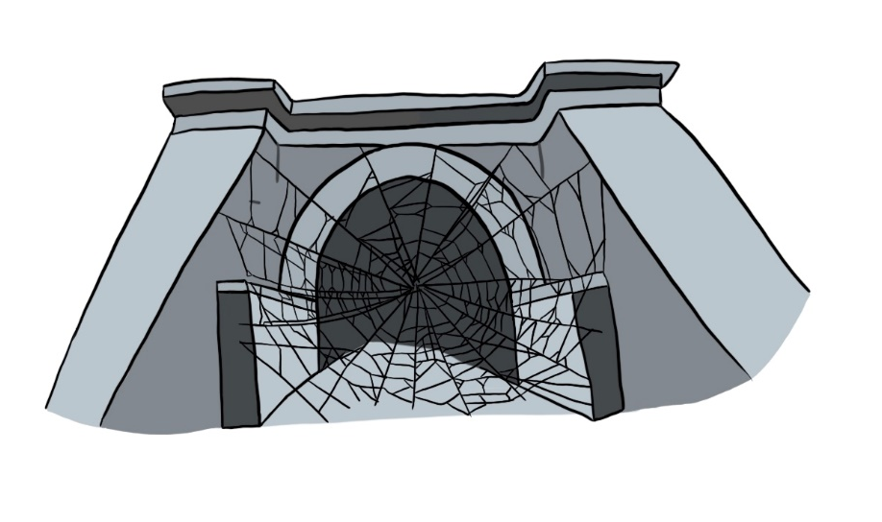

As fast as her tired feet would take her. Ara stumbled down the hall. She shoved on her shoes and before she slammed the door, Ara heard, ‘You are never to see that girl again, Maverick.’ She ran out into the pouring rain, taking one last glance at the house and its luxury.
Ara felt tears falling down her cheeks, mixing with the raindrops. She began the walk back to the lake, shivering from the cold. It wasn’t too long a journey, but it was long enough for her to think and reflect on the evening.
She walked freely through the streets.
‘Hey, cool costume.’ A passer-by said, high on sugar and apple cider.
Ara didn’t respond. She passed old fashioned houses with hanging lights in warm glowing amber. She could smell the delicious treacle and the gooey caramel, malting for the apples. Chocolates and sweet bowls were placed on every doorstep. Fake skeletons guarded the treats. Everything was warm. Ara could only feel the cold.
She passed through the town and slipped down the dark cobbled alleyways of Silke Lane, until she reached the outskirts.
Through the forest, where most dared not go, there stood the tunnel. It was larger than most small buildings. Covered in masses and masses of cobble-webs and spiderwebs, it blocked the whole entrance. Each strand drooped, as if it were centuries old. Rumour has it, the tunnel was older than time itself. The webs were so dense it was impossible to see through to the other side.
Ara looked at Widow’s Tunnel. She tried to catalogue its strangeness to memory. Tomorrow it would be gone forever. It would crumble into a million pieces, like the shattered glass on the Greene’s kitchen floor. She sighed. There would be nowhere for her to call her home once the Tunnel was gone. ‘Home’ to Ara was a place where she felt happy. She had never felt happier than when she and Maverick met outside the tunnel every year on Devil’s Night. Not only was the tunnel being taken away, but her only friend too.
Ara looked up at the moon, surrounded by night clouds and scattered stars. She counted seven in total. Seven scattered stars. Perhaps she could find a new happiness, in something simpler, like the stars that could never be taken away.
She took a few steps closer to Widow’s Tunnel, daring to peek through strands of web. It was too dark to see anything, but when she squinted Ara was certain she could see a tiny beacon of light breaking through.
She stepped even closer, until her nose was almost in contact with the dewy threads. Ara’s wet hair stuck to her forehead and cheeks. The rain was refreshing on her embarrassed skin. She lifted Drac, despite the ache in her arms, and allowed it to run its spiders’ legs over the frame. Frank too was lifted, and its spindly fingers ran over the threads. The spider-hands appeared to be playing the webs, like a string instrument.
They stayed there for longer than they knew, saying goodbye.
The rain had dulled down to a light drizzle by the time they stepped back. The air was still cold as death and Ara shivered once more. She went to turn away from the webs, but she didn’t get a chance.
Two large hands grabbed her by the shoulders and pushed her into the web.
Her body latched onto the strands of silk; stickier than any gum she’d ever chewed. She pulled and tugged, but the web wouldn’t give. She felt like a fish caught in a net. The harder she pulled, the tighter the web gripped. Ara tried to turn and shuffle her body to see who had pushed her, but there was no-one in sight. The space around the tunnel was empty.
Ara screamed, cried out for help to anyone who might hear, but the noises only attracted the webs maker. The threads around her tightened.
First, her wrists were bound, then her feet. She couldn’t move to see what or who was trapping her. Every leg on her spiders’ hands was stitched against the silk. Thread by thread, Ara was covered. Only her eyes were left, the rest of her body coated in masses of web. She could hear scratching, like there was more than one thing trapping her. They were surrounding her, inching closer and closer. The legends and myths of people getting lost in the Tunnel resurfaced in her mind.
She screamed again, but her mouth was muffled and just before everything went black, Ara heard the high cackle of a wicked laugh and caught the glimpse of a pair of sad eyes, peeking out from behind the bushes.

