Bohemian Rhapsody report

Tianyang Zhang
ID ： 10494136
Tutor ： John Burns

Idea：
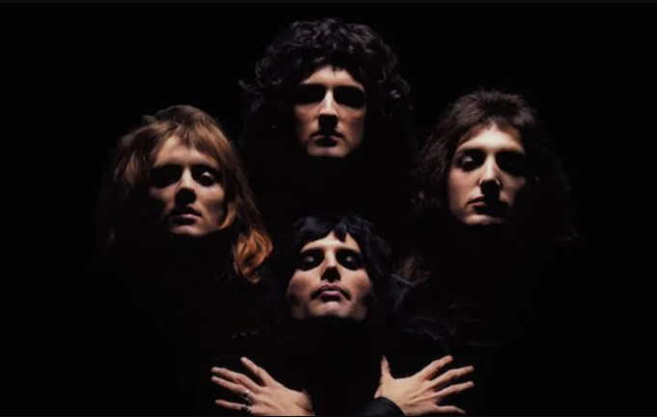
I first learned about the queen band around August last year. I like watching some videos of movie commentary. While browsing these videos, I found a movie called Bohemian Rhapsody (2018). The film won the 91st Academy Awards. The story of the film deeply attracted me. I was also shocked by Freddie Mercury's personal charm and legendary experience in the story. The film tells the story of lead singer Freddie Mercury leading Queen to achieve the most brilliant music road. The most important chapter is undoubtedly the process of creating Bohemian Rhapsody. So I began to want to know Queen. I consulted Wikipedia and some online literature. I know that many familiar songs are the works of the Queen band. For example: When people hear the "Rock and Roll" (1973), they clap and "We are the champions" (1977), which is played at all major sporting events. Bohemian Rhapsody (1975) also has a reputation comparable to the second national anthem of England. My favorite Japanese cartoonist Araki Hirohiko's work JoJo's Bizarre Adventure also pays tribute to Queen. He created a character called Killer Queen. The name of this character is selected from the song "Killer Queen" in Queen's album Sheer Heart Attack.
Queen band
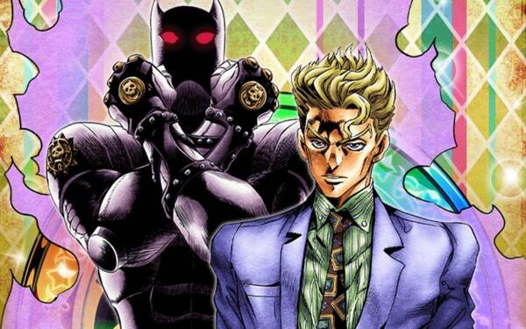
Bohemian Rhapsody has an extraordinary side. The biggest difference of this song comes from its musical structure. This song is neither Acappella, opera, folk songs, nor rock and roll. In fact, this song contains all these contents. Being too familiar with it will become boring. Bohemian Rhapsody is so strange, strange and rare. Before that, there was no such musical expression, and in fact, there was no one coming later. Of course, in addition to the diverse musical styles, there are also their gorgeous stage performances, especially the sexy and bold stage expression of lead singer Freddie Mercury.
Jojo character Killer queen
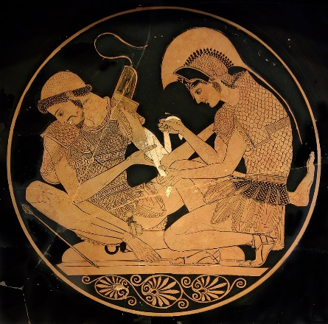
Rhapsody is a national epic sung by ancient bards. There is a well-known story. Encouraged by the gods, the Greeks and Trojans fought for ten years for Helen, the most beautiful woman in the world. Troy was impregnable, and the Greeks hid the soldiers in the belly of a giant Trojan horse and gave them to the Trojans, which finally captured the city. The Trojan War in history took place roughly in the 12th century BC. Although there are words, they are not popular. The story of this war has been handed down by word of mouth from generation to generation. After more than 300 years, it was organized into two epics, Iliad and Odyssey by a Greek named Homer. These two epics add up to a total of 27803 lines, when the text is not popular. People tell people historical stories by singing. Such people are called minstrels. The story told by the bard is called "Rhapsode". If the word refers to literary works, it is called "epic"; If we refer to the musical genre, we are talking about Rhapsody today. In the romantic period, composers began to look for the inspiration of music creation in their national art, so the genre of "Rhapsody" appeared.
Homeric epic
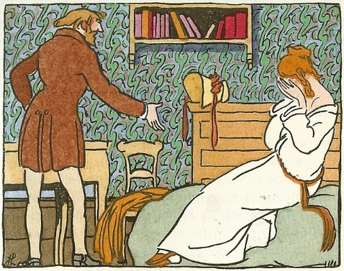
The word "Bohemia" comes from a novel entitled "Bohemian Life Scene" published by Henri Murger, a French poet and novelist. In this book, he depicts a group of artists who are incompatible with the mainstream society, are not bound by social rules, and lead a maverick life. They come from Bohemia, but Bohemia is not their home. Roma's hometown is far away from northern India. They migrated and wandered all the way. One of them had settled in Bohemia for a short time, and then was expelled by the Bohemian king. They fled all the way to France, and the French called them Bohemians. This novel was later adapted by Giacomo Puccini into the opera La bohème, which was a great success and made the image of "Bohemian" spread all over the world. In the mid-20th century, with the rise of rock and roll, "Bohemian" became a cultural symbol, and the resulting "Bohemianism" and "Bohemian Style" became popular all over the world. Bohemianism advocates freedom, rebels against tradition, opposes the suppression of creativity and inspiration by rules and order, and advocates absolute artistic spirit. Bohemian style pursues to show its unruly and personality, without constraints and standards.
Scenes de la vie de Boheme
Queen's works always like to bury some shadows of classical music, and Bohemian Rhapsody's music is a bold combination of various styles, so it has also been called "rock opera". Six minutes, five chapters and four styles. The whole song is like an opera that is unrestrained and keeps improving. Piano Accompaniment - Show inner monologue. Aria - confession of crime. Chorus - show the high of the judgment of the gods. Metal - represents the spirit of resistance. These put different kinds of music together and become an organic whole, and the Queen has undoubtedly achieved the ultimate.
In the process of repeatedly listening to "Bohemian Rhapsody". Some pictures will come to my mind. So I thought about showing this song in the form of animation. This will be an animation in honor of Queen and Freddie Mercury. Because songs are divided into four styles. I intend to use four different forms to express this song. They are the text at the beginning of the song. The storytelling part of the song uses ordinary animation. The climax of the song uses rotoscoping and some live pictures of the Queen's concert. And my favorite opera part is rendered with collage animation.
The first half of the song is mostly lyrical and narrative. Because bohemianism advocates the spirit of freedom and rebellion. I want to join the controversial George Floyd incident some time ago. Nowadays, although slavery has been abolished, discrimination against people of color still exists. The network has no memory. With the passage of time, this matter will be gradually forgotten by people. So I want to add this part to my work. I hope to alert people to recall the protests and anger at that time. It can has the effect of combating racial discrimination.
The use of color is also very necessary. I want the background to be blue, gray and purple. Blue symbolizes depression, sadness, etc. Gray symbolizes conservatism, dignity, etc. Purple symbolizes cruelty, arrogance, mourning, etc. Using these colors can well show the mood of the hero in the story and the effect that Queen wants to express.
After the guitar solo, the piano cut in, prompting the rhythm but no melody, and then a long nonsense lyrics: silhouetto, Scaramouche, Galileo, figaro, etc. This aria seems to contain a lot of information. In fact, it has no meaning, but it rhymes very well and complements the music. This is precisely the characteristic of Italian opera. The lyrics serve the music, not logic, but rhyme smoothly. The arrangement of this piece of music is still exquisite and complex. Solo and chorus are interspersed, and music and human voice are intertwined, which makes people feel dizzy. I intend to show these elements mentioned in the song on the opera stage in the form of collage animation. "Bismillah" means "in the name of God". I consider adding the element of God to my work. If there is God, there are angels and demons. The chorus part of the song wants to be expressed in the way of debate between angels and demons. In the use of color, I use yellow and dark blue to show justice and evil. Because angels and demons are antagonistic to each other, these two colors will appear in the same picture.

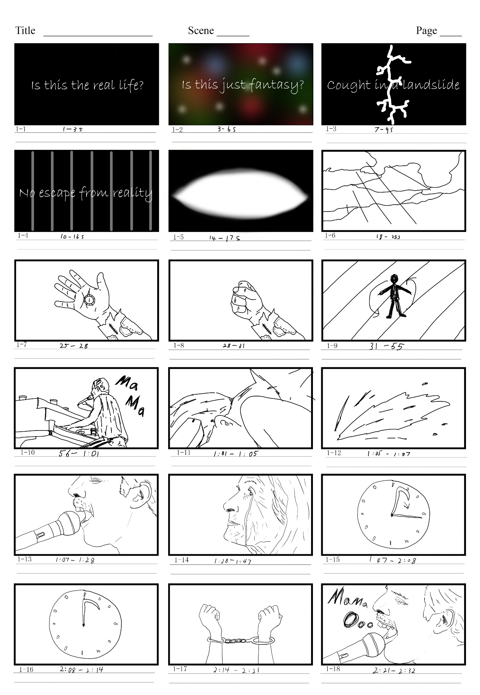
storyboard：

I divided the part before the "Bohemian Rhapsody" opera into the first half of the story version. Because this is an animation similar to MV. I need to divide the story board into paragraphs according to the picture in my mind and the time of the song. Because this is my first attempt to make music related animation. This is a very time-consuming part for me. I need to listen to this song again and again. I slowly match the music with the picture in my mind. Then I confirm the time corresponding to the music and mark it. And I mark the order in the lower left corner of each picture.
The beginning of the song is a multi part canto, followed by piano accompaniment. Each part is intertwined with a sense of hierarchy. The sounds are intertwined, overlapping and dreamy. I use words as an opening. And I present the things expressed by the words in the background. The dreamy feeling is depicted in 1-2. The cracks in 1-3 give a sense of oppression. The lyrics of 1-4 wrote "no escape from reality", so I added a background similar to a cage. 1-5 and 1-6 are designed as the lyrics say, "Open your eyes. Look up to the skills and see." 1-5 I intend to make an animation with my eyes open, while 1-6 is a picture of the sky. The lyrics in 1-7 and 1-8 write "I'm just a poor boy, I need no sympathy.
”So I clenched my fist to show the boy's firm faith in his heart. The lyrics in 1-9 are "because I'm easy come, easy go, a little high, little low, anyway the wind blows, doesn't really matter to me." I designed a figure to be manipulated at will to show the helplessness of the characters.
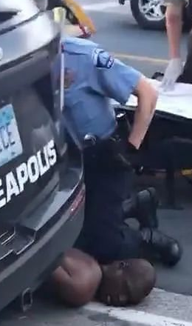
The following narrative ballad tells the core scene of the whole song, the regret of a teenager after killing someone. 1-10 is a small climax of the song. I expressed the climax of the song in the form of rotoscoping. These are very classic live pictures of Queen's concert. The climax parts of songs such as 1-13 and 1-18 also use the form of rotoscoping to paint. The lyrics of 1-11 are written as "put a gun against his head, pulled my trigger, now he's dead.", which is related to George Floyd incident. In this part, I change the perspective to the first person perspective. From the perspective of the protagonist, I make the picture more impact. 1-14 according to the lyrics, it is designed as a crying mother waiting for her son. In the lyrics of 1-15 and 1-16, "too late, my time has come, sends shivers down my spine, body's hitting all the time, goodbye everyone-I've got to go." In this lyrics, the hero intends to face the reality and wait for the sanction of law and God. His time is running out, so I added a countdown clock animation in this part. The hour hand of the clock is a sickle of death, which represents sanctions and the end. The lyrics of 1-17 are "Gotta leave you all behind and face the truth." The hero accepted his fate-his hand was handcuffed by a bracelet. He will face sanctions. The above is the story version of the first part. Due to the tight time, I didn't continue to make the following story version and started to make animation directly. I look for inspiration in the process of making animation.
George Floyd

Production process：
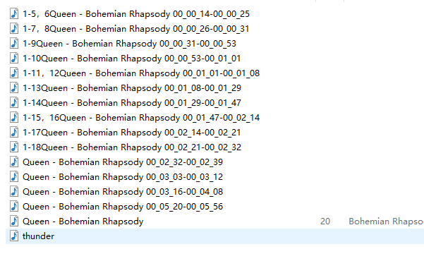
The software I used in this work includes Adobe Photoshop, Format factory, Toonboom Harmony and Adobe Premiere Pro. Before making animation, I first use Format factory to divide "Bohemian Rhapsody" according to the paragraphs marked in the story version. The parts marked in the story board are not completely accurate. This time, I accurately divided the music.
1-1 to 1-4, because these pictures do not last long. The effect of animating these pictures is not very different. This can save some time to complete the following animation. I use Adobe Premiere Pro software to show the picture in the way of cross resolve.
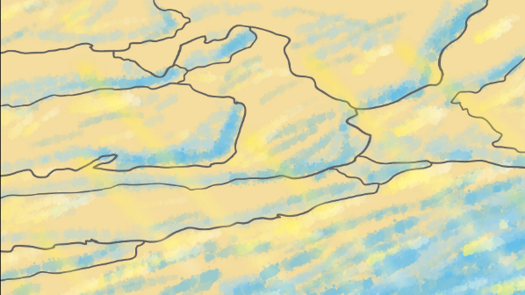
1-6 is the animation of seeing the sky after opening the eyes. This section of the song reflects the protagonist's down but firm heart. I think the sunset sky can better reflect the mood of the characters at that time. In order not to make the picture look monotonous, I made the effect of sunlight penetrating the clouds.
1-6
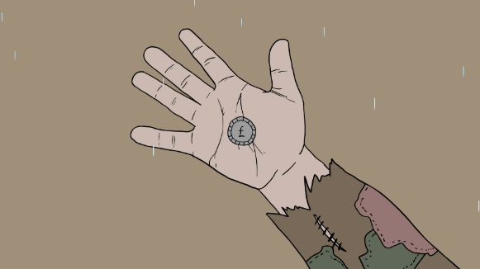
The animation of 1-7 and 1-8 is based on my own hand and designed the tattered clothes according to the lyrics. I designed a sleeve with stitches and patches. I added raindrop animation to highlight the tragedy of the protagonist.
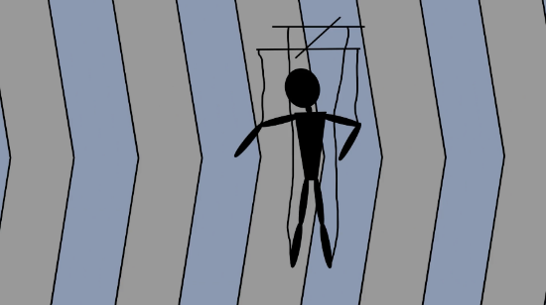
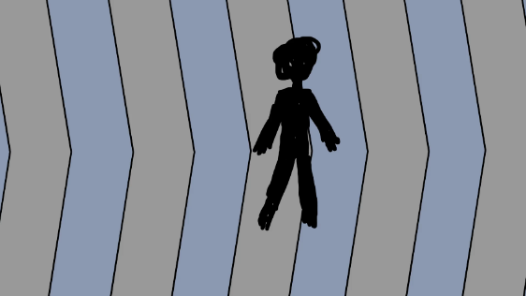
In 1-9, I design the background as an arrow and let the character move with the arrow. It presents an effect of waving and moving. The tone of the background is gray and gray blue, which reflects the protagonist's inner depression. At first the figure didn't move and looked a little rough. After repeated thinking, I decided to make the figure into a string puppet. String puppets can better reflect the character's state. Puppets are not suitable for binding bones. So I created multiple layers. The puppet animation is completed by rotation and translation. The parameter rate is set in the key frame to make the character move more smoothly and naturally.
1 -9 improvement
1 -9
1-7 ，1 -8
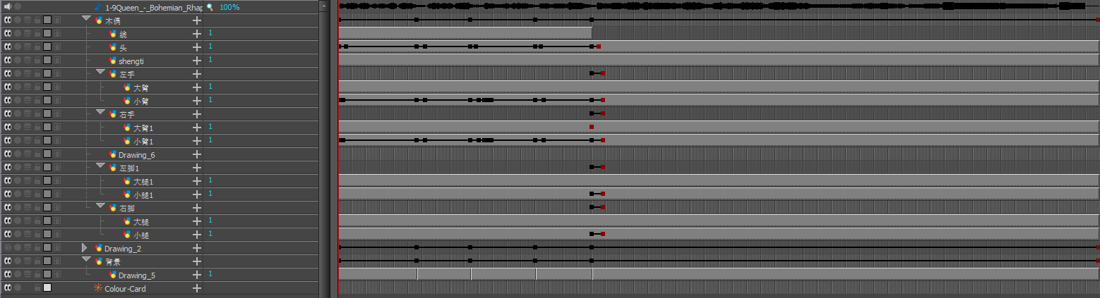
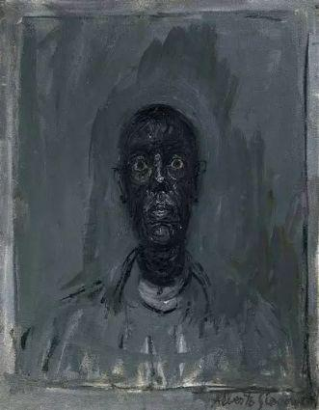
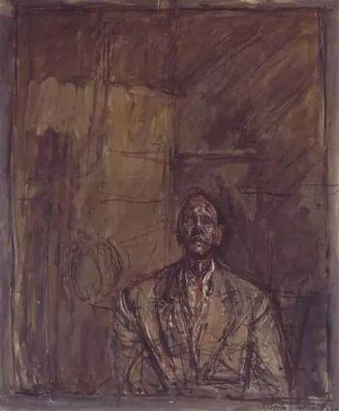
1-10, 1-13 and 1-18 are inspired by Alberto Giacometti's paintings. Alberto Giacometti (1901 ~ 1966), a Swiss super-existentialist sculpture master and painter. Representative works include surreal table, cage, nose and so on. Giacometti is a master of sculpture and a painter. Most of Giacometti's paintings look like sketches. Perhaps they are meant to be the preliminary drawings of sculpture, and they always look unfinished. The main tone is dark gray, and occasionally a little red appears. The characters or still life as the main objects seem to be compressed by the dark power of the picture, squeezed in the corner of the picture, suppressed, humble and powerless. The numerous disordered and unprovoked lines in the picture not only explain the space, but also full of emotion. The seemingly simple but complex lines depict one painting after another that hits the soul directly. We can't help but want to explore the seemingly dusty past behind the picture.
Toonboom:1 -9
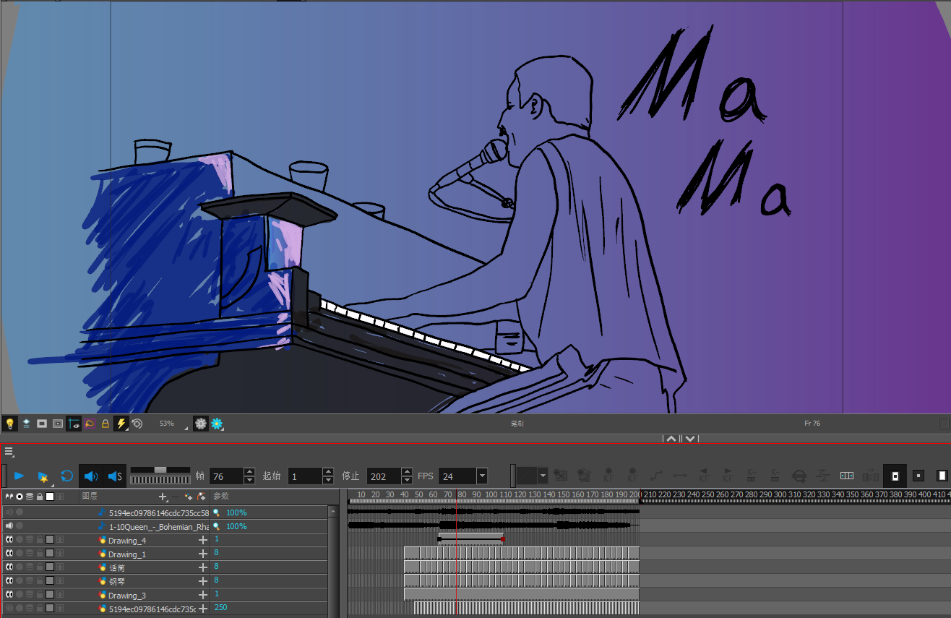
I also want to use simple lines to describe Freddie Mercury's impressive concert scenes. I use color to express the atmosphere of songs and Freddie Mercury's mood when singing. I think my painting skills can't support me to draw these animations frame by frame. So I chose to use rotoscoping to complete these animations. There are still many difficulties in the production process. First, the video cannot be imported into toonboom software. I checked many methods and failed to solve the problem. Finally, a solution was found on the official website. Toonboom only supports videos decoded by QuickTime player. After downloading the QuickTime player, I found that I couldn't open the video using the QuickTime player. So I deleted all the players in the computer. The computer has to open the QuickTime player by default. Finally, the video is imported into toonboom. The next difficulty is the discovery after importing the video. Video and audio are out of sync. After constant modification, Freddie Mercury's mouth shape was paired with the music. In the process of rotoscoping, I found that although it is in the form of rotoscoping, the workload is far beyond my expectation. The animation of 1-10 is a picture of 3 frames. In 1-13 and 1-18, it had to be modified to 5 frames a picture. Half of the content in 1-13 had to be deleted and replaced with the video of Freddie Mercury concert. I colored only part of the object. The character part is left blank. I use the background color to set off Freddie Mercury. The background color uses a gradient of blue to purple and blue to pink. I am very satisfied with the animation effect presented at the end. I use the background color to set off Freddie Mercury.

Toonboom ： 1 -10
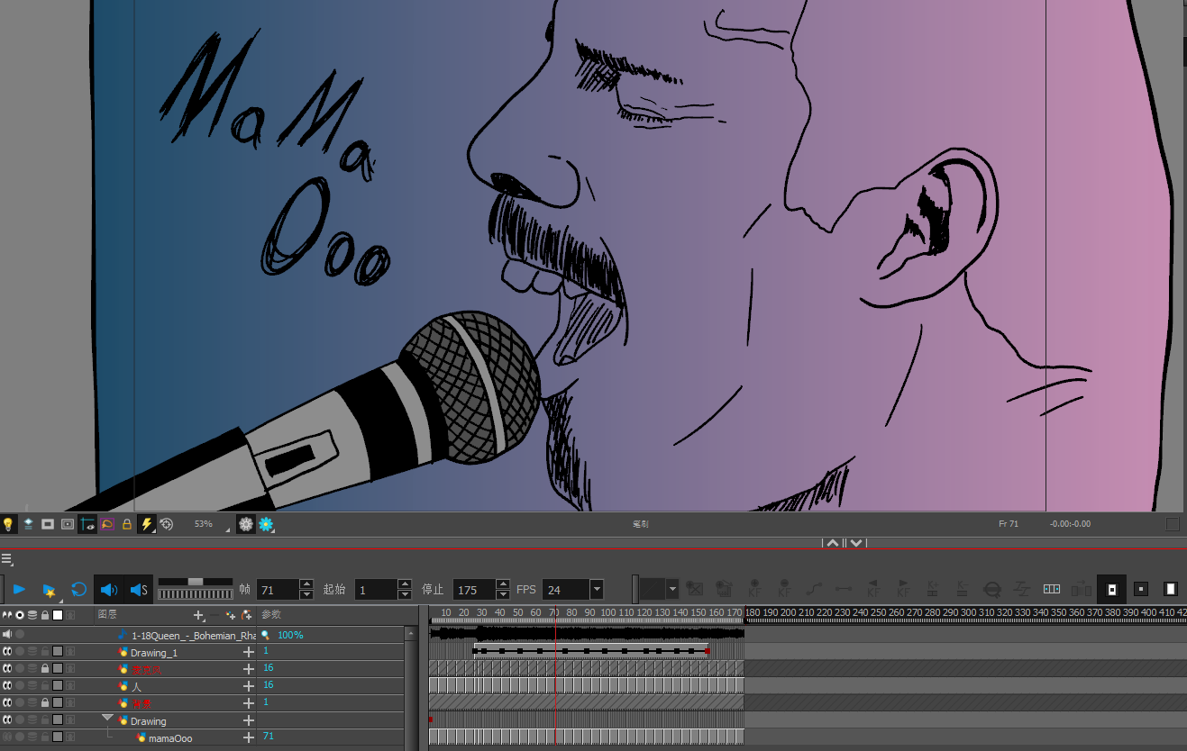
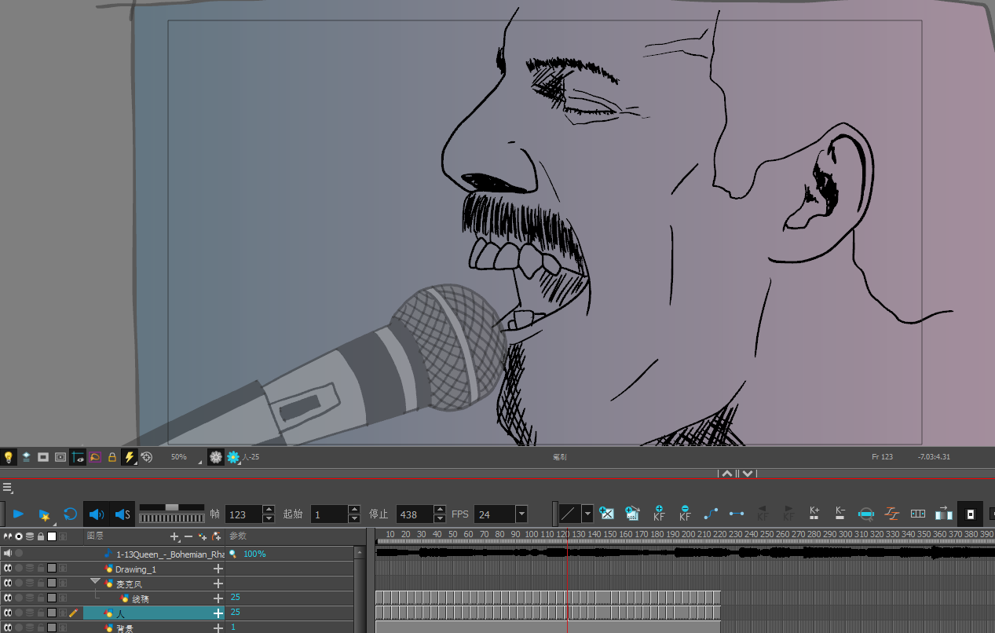
Toonboom ： 1 -18
Toonboom ： 1 -13

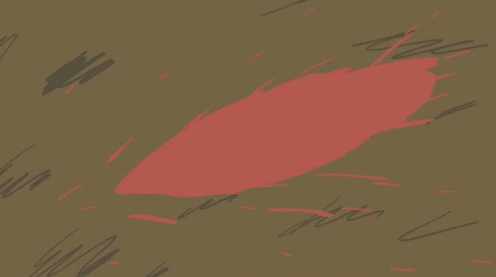
1-12 is an animation of blood splashing. I looked for some pictures of blood sputtering on the Internet as a reference. I've done similar animation effects before. This animation is quite handy.
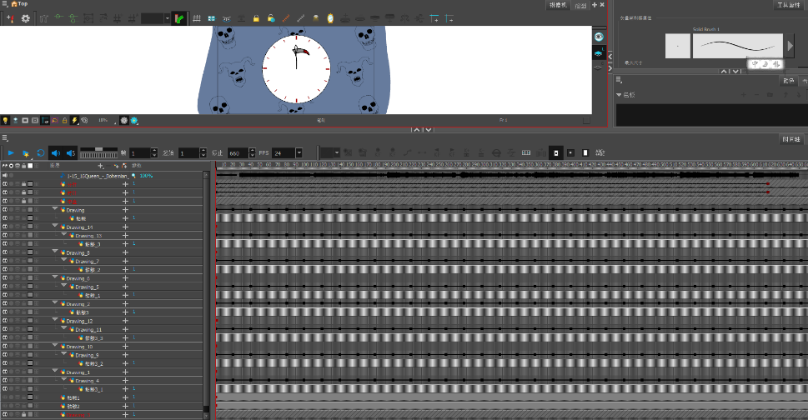
1-15 and 1-16 are countdown clocks. The protagonist will welcome his sanctions. Because this period lasts a little longer, I also added some skeleton icons to the edge of the clock. It makes the picture look less monotonous and boring.
Toonboom ： 1 -15 ，1 -16
1 -12

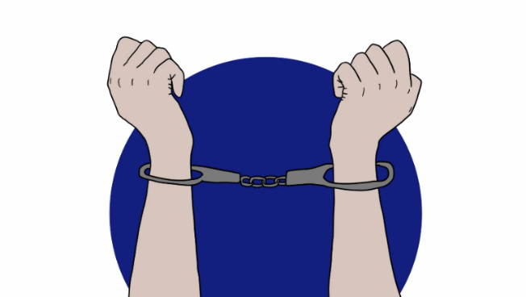
1-17 is an animation of a handcuffed hand rising from the bottom of the screen. This animation is relatively simple. I don't have any good ideas about the background. In order to make the picture look not monotonous, I added a high purity blue as the background. This is also to set off the character's heart. The above parts are all in the story board.
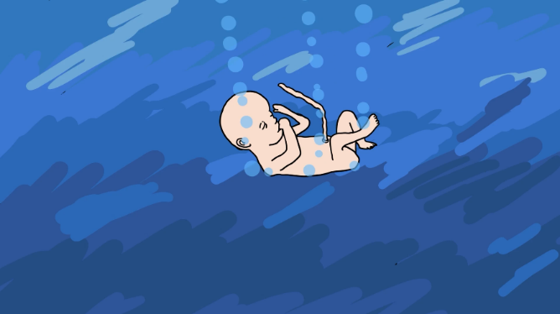
1-19 this is the end of the first part of "Bohemian Rhapsody". The lyrics say "I don't want to die, I some times wish I'd never been born at all." This lyric reflects the hero's inner remorse. Baby is a new life, which also represents the protagonist's desire for rebirth.
1 -17
Then the song gradually entered the second stage. A guitar solo as standard for rock and roll as an interlude. Quietly changed the tune, ended the ballad part and led to the next style.
1 -19
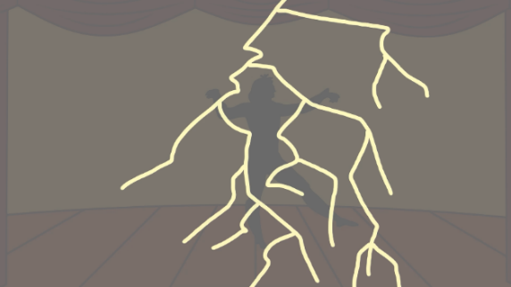
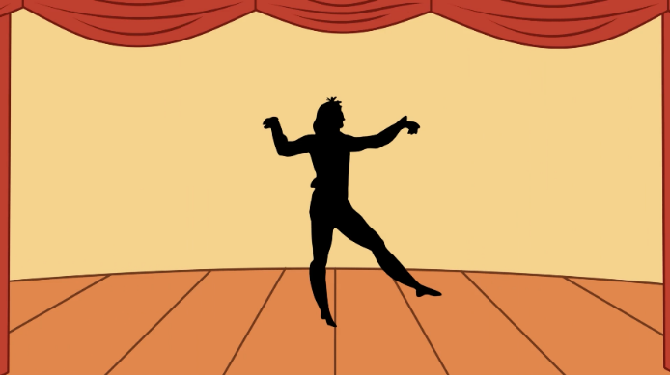
Then the song entered the style of opera. The overall style of animation has also become the style of collage animation. When it comes to opera, the first thing I think of is the stage of the theater. 2-1 as the first act of this stage. I chose to make an animation to build a stage. Parts of the stage fell from above the screen - the show began. According to the lyrics, I only performed a scene where a figure danced Fandango.
2 -1
"Thunderbolt and Lightning-Very Lightning Me" made an animation of lightning chopping in 2-2. The transparency of the animation is adjusted with Premiere Pro. It gives lightning a flash effect on the stage.
2 -2
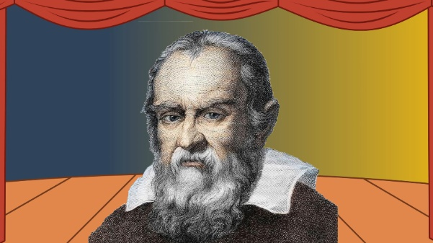
Then the song enters the part of "pseudo opera". I found a picture of Galileo in Google pictures and used Photoshop to select Galileo's mouth with lasso tool. Export PNG. Format pictures of mouth and head separately. Then import the picture into the toonboom file.
2-2
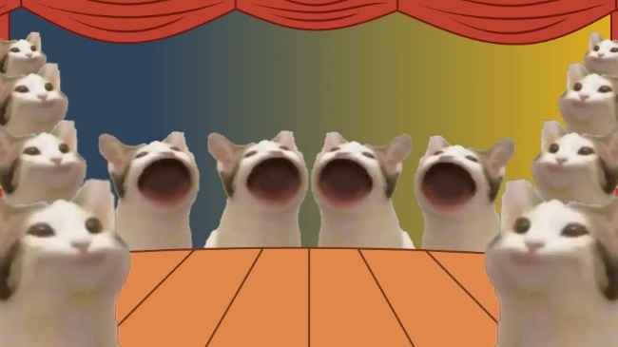
I like to add some funny elements to all my animation works. Because it makes the animation look interesting. This work is no exception. Pop cat is a very popular GIF picture on the Internet. I think it's very appropriate to animate it and add it to the chorus of the song. This can increase the interest of the short film. It is also in line with the characteristics of lyrics that do not seek logic.
2 -3
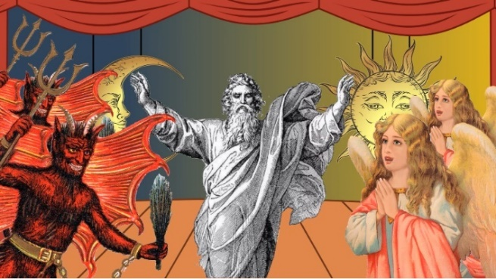
In Part 2-4, I designed it as the effect of arguing between angels and Demons according to the lyrics. God symbolizes the balance in the middle of the picture. I found the bohemian classical style sun and moon on the Internet as the background, representing justice and evil, which are located on the left and right of God. God, angels and demons did the same thing as Galileo.
2 -3
I finished the animation of 2-3 and 2-4 together. This is really a very heavy part of the workload. I want to move the character's mouth according to the music. This ensures that the character's mouth can match the music. The parent-child relationship of layers is also very important. I need to make sure there are no mistakes.
2 -4

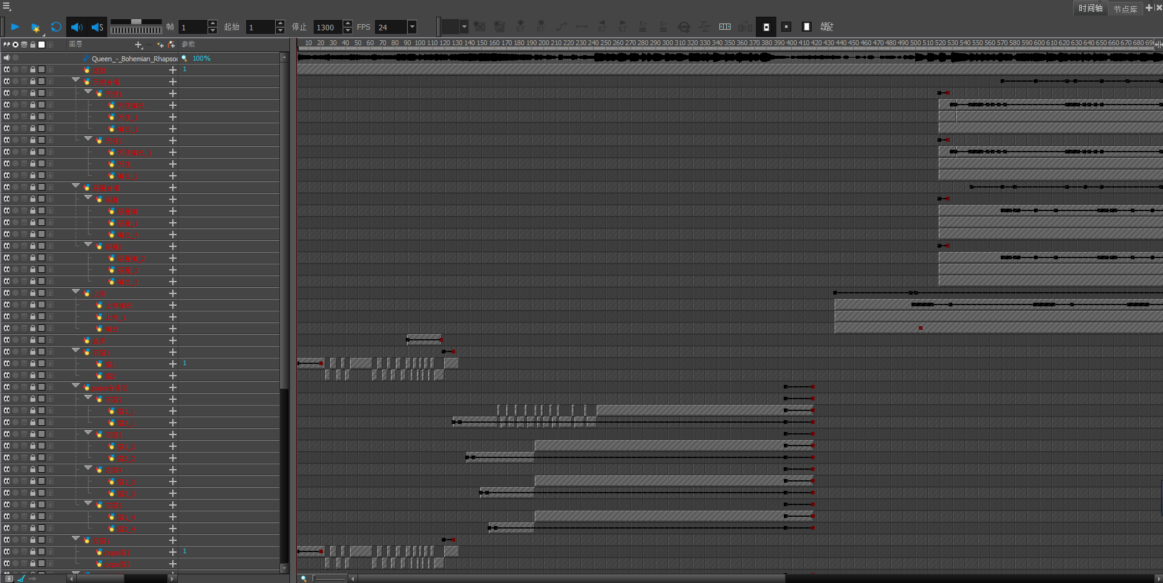
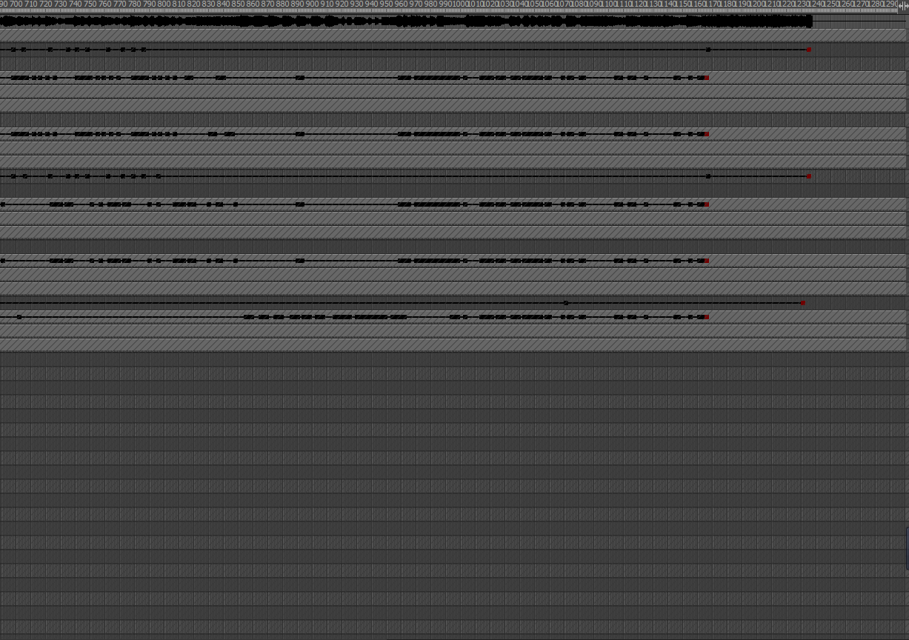



Toonboom：2-3，2-4

Summarize ：
Finally, the editing. In part, I also encountered places that bothered me. All parameters are default when creating a Premiere Pro. After editing, I found that the resolution of the video was wrong. I inquired about various methods to modify the resolution, which can't be solved. The only way to modify the resolution is to adjust it in the default sequence. However, as long as the parameters are modified, all videos will be deleted. I had to re edit the video. I think this will be a lesson. In the future, I will check the parameters more carefully to prevent unnecessary trouble.
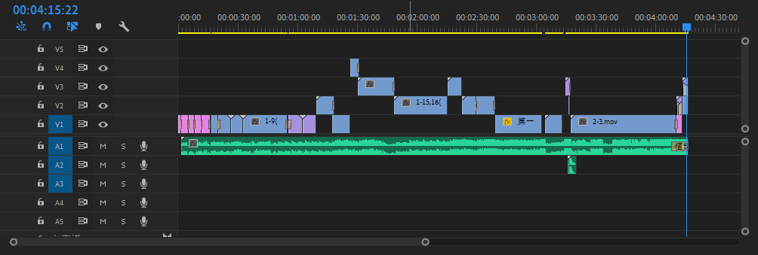
This is the first time I have done such a long animation. One can't make an animation for nearly 6 minutes. The animation of "Bohemian Rhapsody" ends when it comes to "pseudo-operatic". I didn't continue to make the back part because the back part of the song is mostly accompanied by rock and piano. The lyrics are pure emotional catharsis, which is difficult to be expressed in animation. Secondly, making the first and second parts consumed too much energy. I'm too tired to have more time to finish the later part. It's a pity. But I'm still quite satisfied with the final product.
Premiere Pro Editing
Finally, thank you very much for John's help and teaching over the past year!

Reference

Bryan Singer，（2018 ），Bohemian Rhapsody，Rami Said Malek

Queen (band)，（ 1971），https://en.wikipedia.org/wiki/Queen_(band)

Freddie Mercury， https://en.wikipedia.org/wiki/Freddie_Mercury

Araki Hirohiko，（ 1987 ），JoJo's Bizarre Adventure

Rhapsode，https://en.wikipedia.org/wiki/Rhapsode

Bohemianism，https://en.wikipedia.org/wiki/Bohemianism

Homer ，Iliad， https://en.wikipedia.org/wiki/Iliad

Homer ，Odyssey， https://en.wikipedia.org/wiki/Odyssey

Henri Murger ，（ 1851）， (original French title: Scènes de la vie de bohème)

Giacomo Puccini，（ 1893-1895），La bohème (/ˌlɑː boʊˈɛm/; Italian: [la boˈɛm])

Colour meaning, https://www.incredibleart.org/lessons/middle/color2.htm

Queen - Bohemian Rhapsody (Live at Rock Montreal, 1981)， https://www.youtube.com/watch?v=N0dbGGvsjf8

Queen - Bohemian Rhapsody (Live In Budapest, 1986)， https://www.youtube.com/watch?v=bMPOMT251mQ

Queen – Bohemian Rhapsody (Official Video Remastered)， https://www.youtube.com/watch?v=fJ9rUzIMcZQ

George Floyd， https://en.wikipedia.org/wiki/George_Floyd
Alberto Giacometti，（10 October 1901 – 11 January 1966
https://en.wikipedia.org/wiki/Alberto_Giacometti

Galileo Galilei，http://siaoyin.com/Info/543268012157104565

Bohemian classical art style sun and crescent moon，https://www.shutterstock.com/zh/image-vector/antique-style-hand-drawn-art-sun-523540135

God，https://www.pinterest.com/pin/296322850487165608/

Angle，https://pixabay.com/zh/illustrations/vintage-angel-angel-praying-5351396/

Devil，https://www.newyorker.com/humor/daily-shouts/the-devil-critiques-expressions-that-mention-him

