Layout for a reading lesson:

Section 1:

The text I have chosen is from an article from the ‘BBC News’ website (appendix 1), to use with learners who are pre-intermediate. The register of the text is formal, as it is an article from a newspaper, explaining the events that took place. Having a formal register makes the statements/facts given more trust worthy and reliable. Not to mention, articles are often accessed by many people in our day to day life, so the learners would be familiar with the layout and style. The article talks about a couple who became stranded on an island, and how they managed to get rescued. This article is an interesting one for learners as the couple manage to receive help using a unique method. It can create a lot of discussion between the learners as they can talk about ideas they might have, in regards to being stranded. Or if they’ve ever been in a situation where they needed help and what their opinion on this article is. The article I have selected is 474 words, it uses a few lexis items which learners may not know the meaning of. Such as ‘uninhabited’, ‘deploying’, ‘capsized’ etc. So, this would be a good opportunity to define them and pre-teach to expand the learner’s vocabulary. “Two studies found that pre-teaching vocabulary had a significant effect on comprehension” (Carter and Mccarthy, 2013:100).
Section two:
For the lead-in, I will put the learners in small groups of three and have them come up with a list of 5 things that they would need, or think is necessary if they were stranded on an island. Each group will be given a sheet to make their list on (appendix 2). This is a good activity as not only is it personalised, but it is also engaging and is a good way to activate schemata. It requires learners to use their imagination, and have them activate their thought process, and thinking about the topic of the lesson. On the PowerPoint I would put images of a few important items that could be taken, just to prompt the learner’s ideas, and help create discussion between the groups. For example, a first aid box, packaged or canned food, warm clothing etc. This is a good task for pre-intermediate students, as making a list is a simple task and allows them to practise their use of vocabulary.
Section three:
For the initial reading task, I have chosen to give the learners a prediction task where the images from the article will be put on the board (appendix 1). Learners will discuss in partners what they think is happening in the images. Learners will come up with their own thoughts and opinions about the images and discuss with one another. A good way to receive feedback would be a class discussion about the images. Showing the learners the images before giving them the text will make them more interested and curious about the text they are going to read. They will then be given a time limit to quickly skim read over the text, to get the general gist of the content. This will allow them to check whether their thoughts on the images matched up with the article and give me feedback. Learners will have come across some vocabulary in the text that they may not understand, so this would be a good point to pre-teach the vocabulary, through a matching activity using picture definitions (appendix 3), as I would have already verbally defined the words on the PowerPoint. This is a good way to check whether learners have fully understood the definitions of the vocabulary.
Section four:
For the second reading task the learners will be given a comprehension task which I have created (appendix 3). In the task they will be given a variety of questions, which they will have to read the article in detail in order to answer. “This is typically a stop / start kind of reading, involving going back over small pieces of the same text a number of times to find out more and more about it, making sure that the words have been interpreted correctly” (Scrivener 2011: 264). This will test their understanding of the text and develop their reading ability. After taking the time to read, understand and answer the questions, the learners will discuss their answers with the person next to them. This way they can help each other with questions they may not have understood and confirm their answers. This task will be completed with a class discussion where we will go through the answers together. Through this the learners will gain a deeper understanding of the article, how the couple managed to receive help, and what they should do if they ever end up in this situation.
Section five:
To finalise the lesson, there will be a more productive activity (appendix 4) in which I will put up on the board a text message from a ‘friend’, saying that they are in need of help and are stuck on an unknown island with not much to support them. The learners will be asked to write a response/message back to their ‘friend’ giving advice on what to do until help arrives. Seeing as “text messaging has meant that there is now a huge increase in written communication” I felt learners would be more familiar and comfortable with using this writing style (Scrivener 2011:234). On the power point there will be an example of how I would begin writing the message, “Don’t worry! I’ve called for help to be sent, please until they come take my advice and do this…”. This is a good way for learners to build on their imagination and test what they understood from the article. They will then exchange their written work with their partner and read what advice they would give to their ‘friend’, and then some learners will be asked to read out what their partner wrote.

References:
Carter, R. and Mccarthy, M. (2013). Vocabulary and Language Teaching. New York: Routledge, p.100. [online] available at: https://books.google.co.uk/books?hl=en&lr=&id=j2LXAwAAQBAJ&oi=fnd&pg=PA97&dq=pre- teaching+vocabulary&ots=ikGTU1JhmW&sig=ccMfnk71_bae1gV-ELSOyWsEJzM&redir_esc=y#v=onepage&q=pre-teaching%20&f=false [Accessed: 22 Feb. 2020]
Carter, R. and Mccarthy, M. (2013). Vocabulary and Language Teaching. New York: Routledge, p.100.

Appendices:

Appendix 1- sourced article

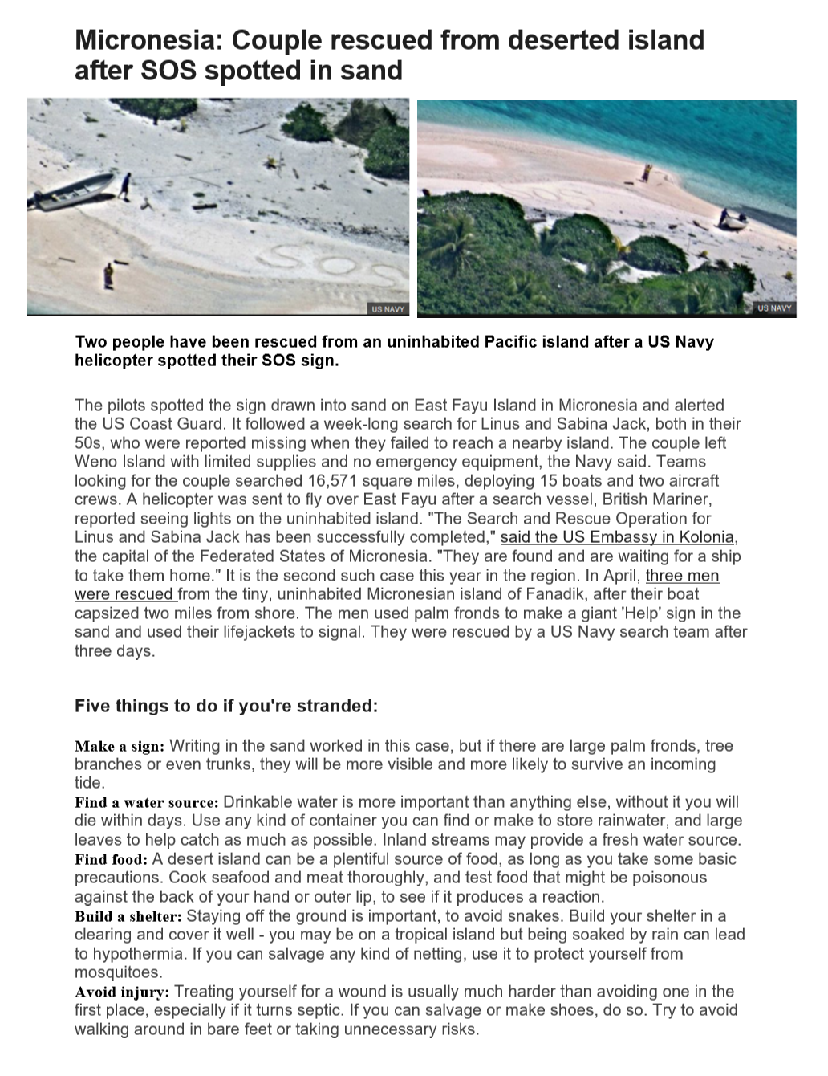
https://www.bbc.co.uk/news/world-asia-37203796
Appendix 2-
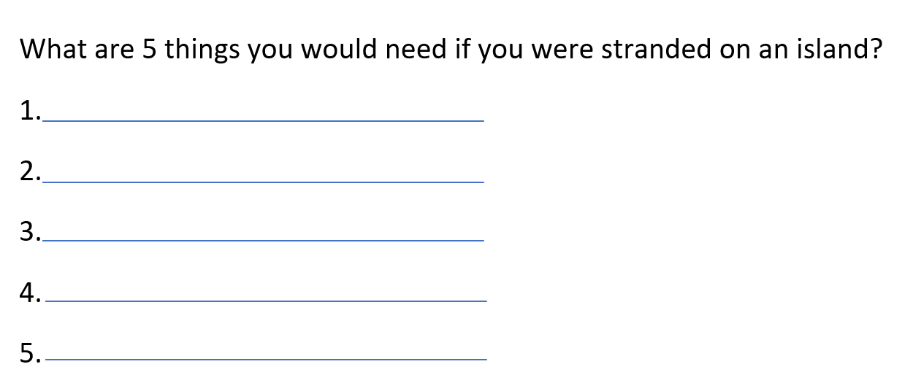

Appendix 3-
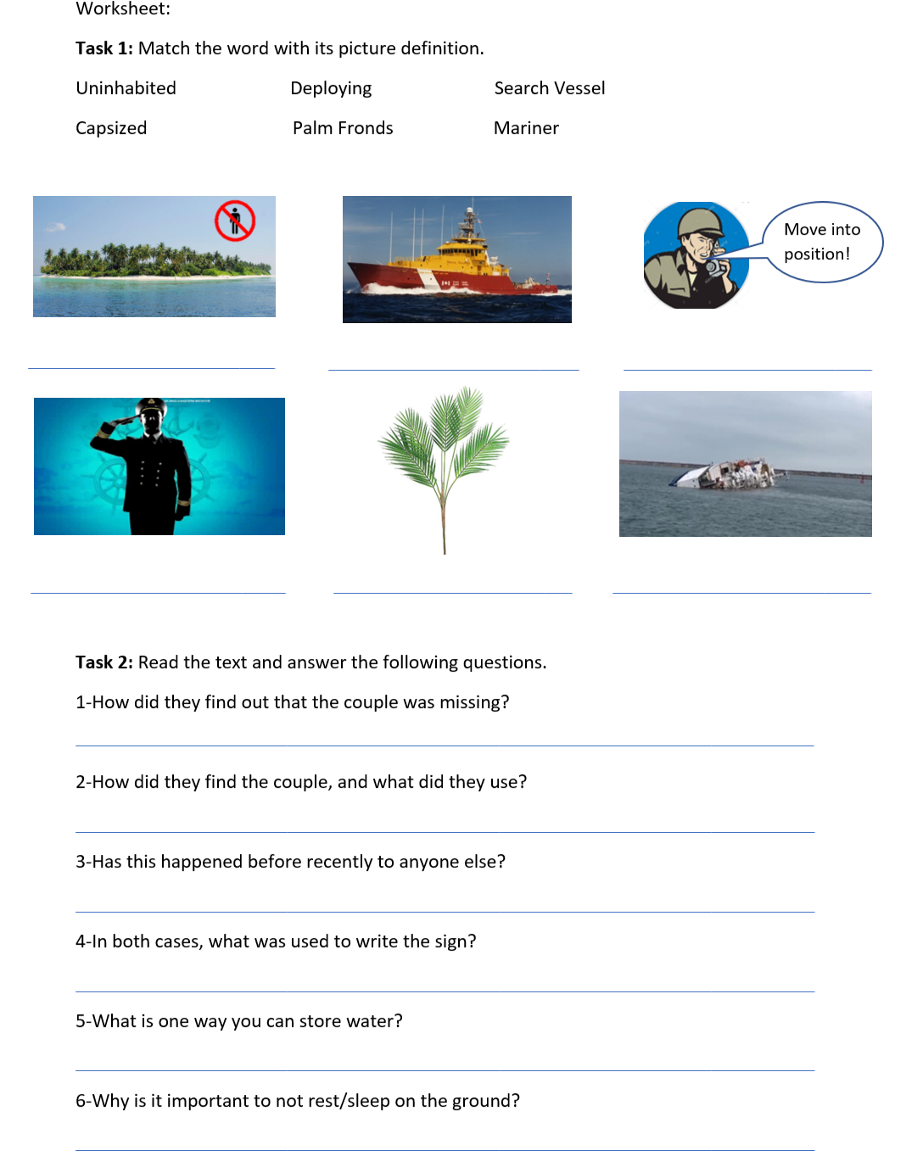

Appendix 4:
